THE CHURCH OF ST ANDREW AND ST PAUL
Harassment Policy
Protocols and Procedures

BACKGROUND
These protocols are prepared in response to Overture No 15, 2019, and the Harassment Policy approved at the 2021 General Assembly (directions to these documents may be found under Resources at the end of this document.)
Harassment means physical or verbal behaviours against a member, adherent, volunteer or employee in the church that are unwelcome or should be known to be unwelcome. It generally persists over time; however, serious one-time incidents can also occur. Also, in our multicultural church, sensitivity is needed to differing cultural values
Harassment is used herein as a generic term, but includes bullying, sexual and racial harassment, and workplace harassment.
The Policy applies to all members, adherents, staff and volunteers of The Presbyterian Church in Canada.
Points highlighted in this policy include an emphasis on training – all employees and volunteers of the Church are to receive training on the contents of this policy; timeliness in response to the event – 30 days is recommended; and a strong and effective communication strategy of the policy and its implications to the congregation is required.

VISION
That The Church of St Andrew and St Paul be a loving, caring, and Christian organization, where harassment, bullying or abuse of any kind will not be tolerated.

SPECIFIC PROTOCOLS AND PROCEDURES FOR THE CHURCH OF ST ANDREW AND ST PAUL
- As a core principle, and as a Christian community, care and compassion should be the basic philosophy in all we do.

- In any normal organization, friction occurs in interpersonal relationships, of various complexities. Our church is no exception. And Jesus even describes them, with his own suggested course of action, in Mathew 18:15-17
- The first level of complexity, and the most common, is a misunderstanding. As a general concept, and as sisters and brothers in Christ, the first step should be for those most directly involved to meet together, privately, to see if they can resolve their differences. This is the normal way to act in a congregation.

- The second level is when those affected would like to have a third party help them to reach amity – perhaps the minister, an elder, or a wise and respected member of the church. Again, confidentiality is a paramount concern, and mutual resolution is the goal.

- If it is found that the situation is more serious (the denomination has provided a check list to determine the seriousness of a situation, see below) then it is necessary to decide if this is an internal or external matter, and what human and other resources should be applied to the situation.

- If it involves sexual harassment, the Church will transfer it immediately to the police – and the Session, the Minister, and church operational groups will step back to allow the police procedures to be carried out by them.

- If it is determined that it is not a police matter, but still serious, then there are several steps suggested – a) A formal Incident report should be completed soon after the event, when memories are fresh, and forwarded to the Moderator and Clerk (the form should be readily available on line.) b) The incident may also be reported verbally to the organizer of any committee or event, who should forward the verbal complaint to both the Moderator and the Clerk. c) A group of three people may be chosen to assist in resolution of the matter - wise, experienced, neutral and not perceived as biased by the complainant. Procedures for the actions of such an investigating committee are enumerated in the PCC link below. d) Timeliness of review of the situation and contact with the complainant is essential – it is suggested by the Presbyterian Church in Canada that 30 days is the preferred amount of time within which interviews and resolution should take place.

- Members and adherents of the Church who are trained in Human Resource principles or have other relevant educational experience; psychologists; and social workers should be identified within the church family. These persons would be given information about the Presbyterian Church in Canada harassment policy and asked to provide support when needed.

- It is suggested that legal advice may be sought by the complainant, if they wish, but that their lawyer should not be present at any interviews (because this is a power difference between the complainant and the committee, if the latter also does not have their legal advisors present) – however, it is perfectly acceptable for the complainant to get advice from a lawyer(s), have them draw up suggested questions or comments, and have them review the discussion after the fact. The Church may also retain legal advice.

- Very importantly, the church fellowship (members, adherents, staff and volunteers) will be trained in the Protocols and Procedures through written and oral means, meetings, newsletters, websites and any other means of dissemination. Such instruction should include, but is not limited to, the formal harassment policy; all locations of the Incident report forms(church website; the church office); the reporting process and steps; an assurance of confidentiality of process and discussion; and how and to whom the results will be communicated.

- The church will place a visible notice in each room of the Church that states “The Church of St Andrew and St Paul is a harassment-free environment. Harassment of any kind will not be tolerated - and will be addressed”.

- It is also suggested that at all events, activities, and Session, Board of Trustees, and Committee meetings, a two-sentence notice will be read at the beginning of each meeting “The Church of St Andrew and St Paul is a harassment-free environment. Harassment of any kind will not be tolerated and will be addressed.” The practice of this announcement should initially be for one year. After that, it should be reviewed to determine whether the practice needs to be continued.

- And it should always be seen, and so communicated to the Church as a whole, that the protocols and procedures are part of a very caring, positive policy, and a comfort to the congregation that the structures are available, well organised, proven, and safe, and that we truly are working to be a caring church community.

RESOURCES

Overture no 15, 2018 (A&P 2018, pg 496; A&P 2019 pg 316-320.
https://presbyterian.ca/wp-content/uploads/2021 _Policy- and-Procedures-for-Addressing-Harassment- in-the-Church.pdf

POLICY - The Presbyterian Church in Canada website
presbyterian.ca – search - Leading with Care – policy and procedures for addressing harassment in the church

Church Harassment Policy check list
Racial harassment flow chart
Procedures flow chart for Session
Church report form

Matthew 18:15-17
‘If your brother sins against you, go and tell him his fault, between you and him alone. If he listens to you, you have gained your brother. But if he does not listen, take one or two others along with you, that every charge may be established by the evidence of two or three witnesses. If he refuses to listen to then, tell it to the church. And if he refuses to listen even to the church, let him be to you as a Gentile and a tax-collector.”

These protocols and procedures have been created in the context of Mathew 18:15-17, noted above, and in line with the Harassment Policy which was approved at last year’s General Assembly, the philosophy and principles of Leading with Care, and is consistent with our Book of Forms.

Approved by The Kirk Session of The Church of St. Andrew and St. Paul on December 1st, 2021.
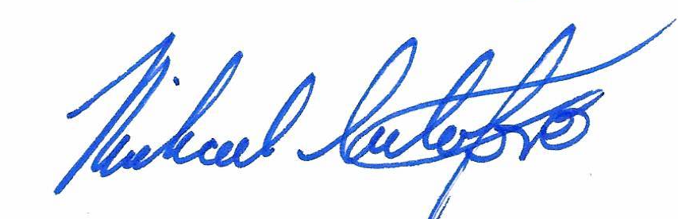
Michael Cristofaro – Clerk of Session

